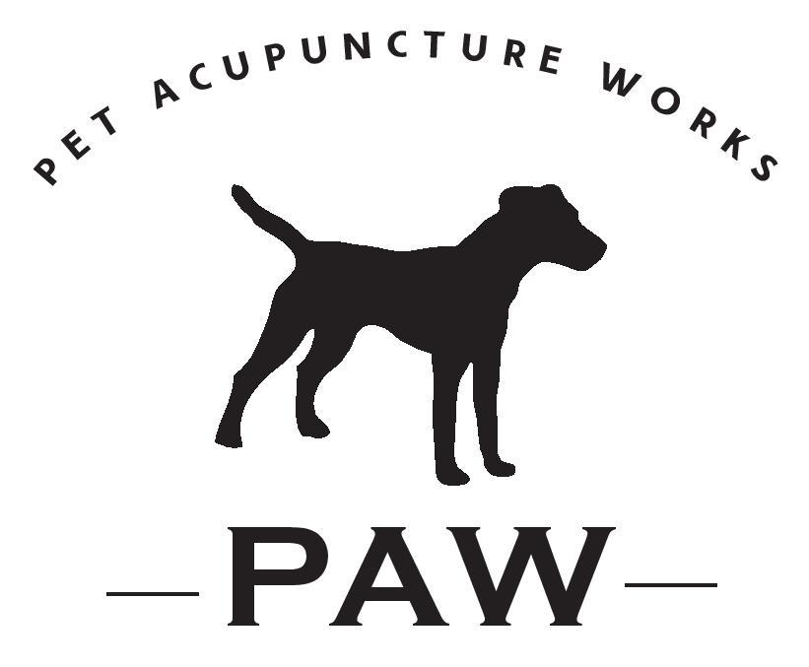
Informed Consent

Pet Owner’s Name: _________________________________________Date:______________
Address: ____________________________________________________________________
City/State/Zip:_________________________________________________________________
Best Contact Number::________________________Email:_____________________________
Pet Name:____________________________________________________________________
Where did you hear about Pet Acupuncture Works? __________________________________
Vet Practice Name:____________________________________________________________
Veterinarian’s Name:___________________________________________________________ Address:____________________________________________________________________ City/State/Zip:________________________________________________________________

The person listed above has requested acupuncture treatment for their animal. All animals must receive concurrent care from a veterinarian and the veterinarian needs to approve acupuncture before the animal can be seen. Please check the appropriate boxes listed below. Thank you.
I hereby authorize: I do not authorize:
▢ Acupuncture ▢ Acupuncture

I give Pet Acupuncture Works (PAW) permission to take pictures of my pet and me and post them on the PAW Facebook page, website, etc. Please check one box: Yes ▢ No ▢
[If you do not want us to take pictures of you, but don’t mind us using pictures of your pet, check here: ▢] Notes/Comments on Animal:
____________________________________________________________________________________

____________________________________________________________________________________

Signature______________________________________ Date__________________

Printed Name___________________________________________________________

